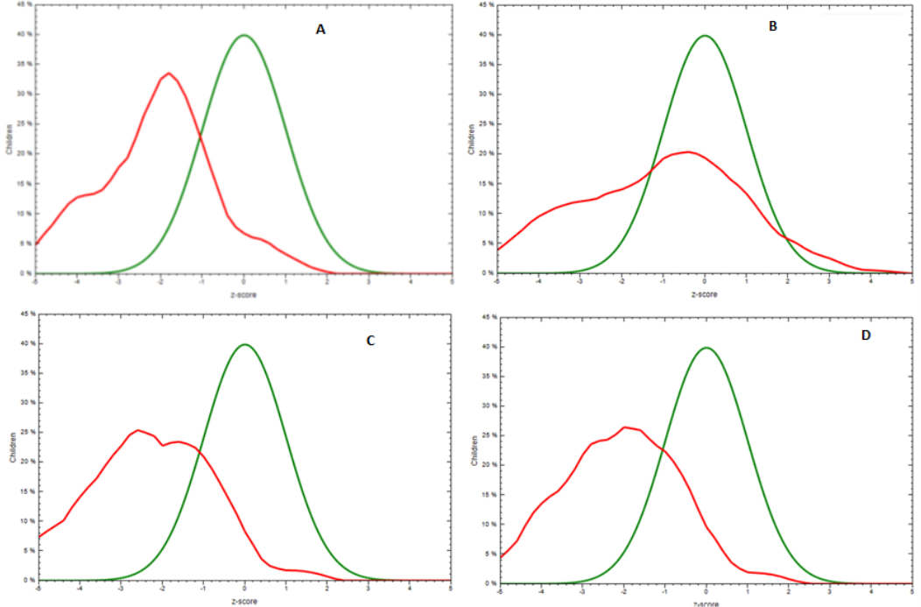 Additional File 3 (Additional Figure)

